Using the formula below ([source](https://physics.nyu.edu/~physlab/GenPhysI_PhysII/Intro_experimental_physicsII_write_ups/Magnetic-field-circular-coil_01_30_2017.pdf))

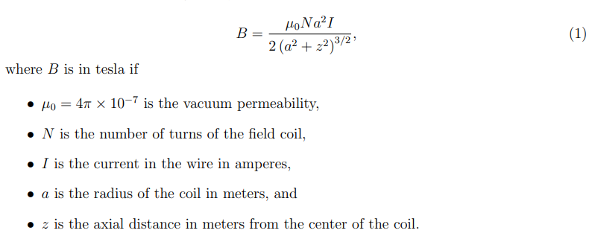

The current to output to antenna is estimated to be 2 A:

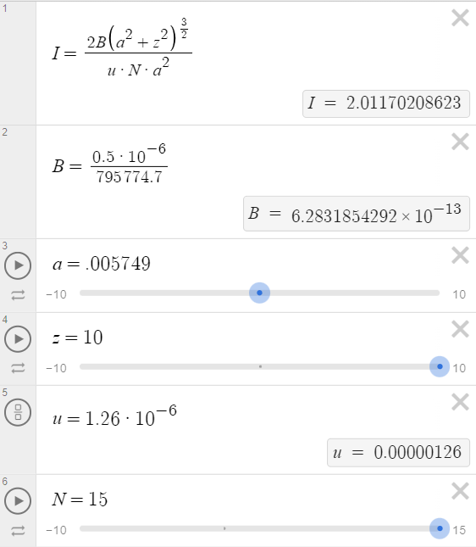

This can be achieved with the circuit below:

